**Conceptual Modelling(ER Model- 1)**

**Entity-Relationship Model**

**ENTITY-** A distinguishable Object of a DB.

Example: Library

Entities can be – Book, Customer, Suppliers, Library_Staff, Authors.

Now, there can be many Entities having the same structure…they can be grouped and called Entity Set.

**Entity Set:** Collection of Entities of Same Type.

**Attribute:** It specifies a part of an entity structure. (In simple words, it’s the column of a Table)

It is a mapping from an entity set to a Domain of Values.

Example:

**Entity:** Book -> **Attribute: i.** Title: 🡪 Mapping to a String(10)

ii. Author: 🡪 Mapping to a String(20)

iii. Year of publication: 🡪Mapping to number, INT(4)

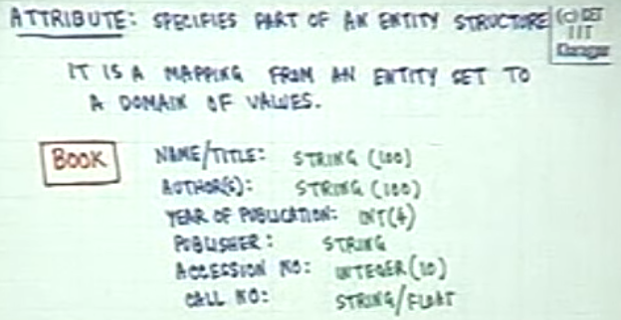

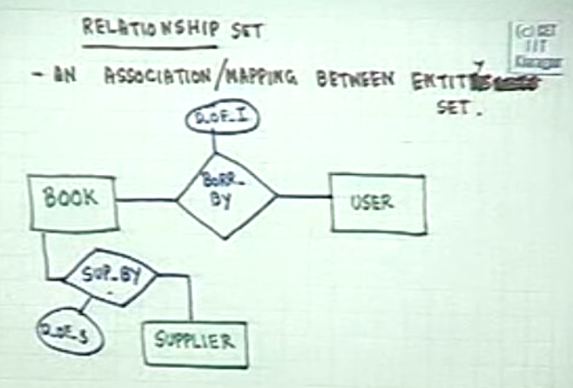

**Relationship:**

An association/mapping between Entities.

The Relationship can be considered as a mapping set where some or none value of an Entity 1 is mapped to Entity 2.

It is not necessary that every element in Entity 1 should have a mapping in Entity 2.

**Note:** A relationship can have an Attribute that is of its own, and is not present in either of the Entities.